Installation eclipse :
Télécharger et extraire : eclipse-jee-kepler-SR1-win32-x86_64.zip
http://www.eclipse.org/downloads/download.php?file=/technology/epp/downloads/release/kepler/SR1/eclipse-standard-kepler-SR1-win32-x86_64.zip&mirror_id=514

Installation gestion de conf (GIT)
Source : http://www.vogella.com/articles/EGit/article.html#egitscope

Installation
The EGit plug-in can be installed into every Eclipse IDE installation. Usually EGit supports the last two Eclipse releases.
Most Eclipse 4.2 and Eclipse 4.3 downloads from Eclipse.org contain EGit in their default configuration. In this case no additional installation is required.
If the EGit plug-in is missing in your Eclipse installation, you can install it via the Eclipse installation manager. Start this manager via the Help → Install new Software menu entry.
EGit can be installed from the following URL:
http://download.eclipse.org/egit/updates
The dialog to install EGit is depicted in the following screenshot.
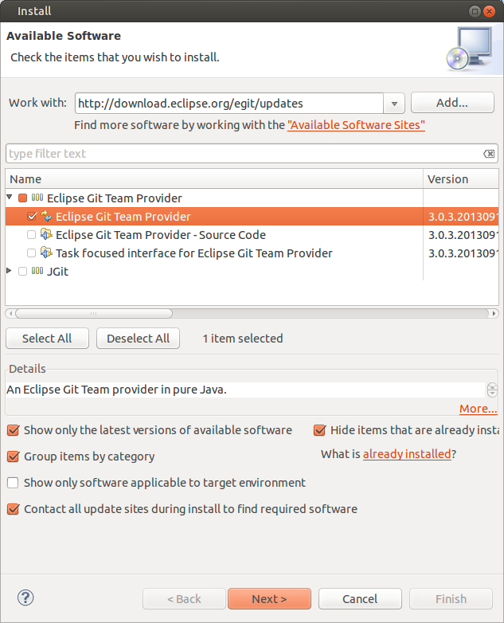

Setting up Git in Eclipse
Before using EGit you should configure your name and email address which is used to fill the author and committer information of commits you create.
Git configuration settings can be configured using the EGit configuration preference page but this configuration is not stored in the Eclipse preferences store but in git configuration files in order to ensure that native git sees the same configuration.
The Eclipse Git functionality allows you to configure your default user and email address for a commit. Select Window → Preferences → Team → Git → Configuration to set them up.
You can add entries to your Git configuration by pressing the Add Entries button on the Git Configuration preference page. To add your user, use the user.name as key and your real name as value. Repeat the procedure for your email address.
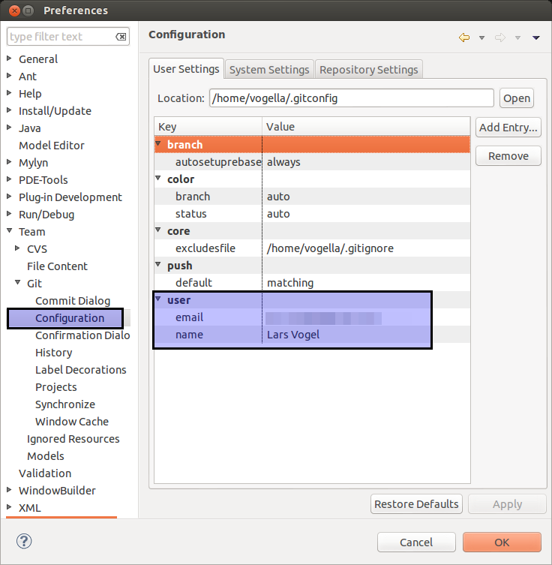
You can add more values in this dialog. These values are stored in the same way the Git command line would store them, so that you can use EGit and Git for the same Git repository.
You can also enter the default folder for storing Git repositories via the Window → Preferences → Git → Team → Default Repository Folder entry.
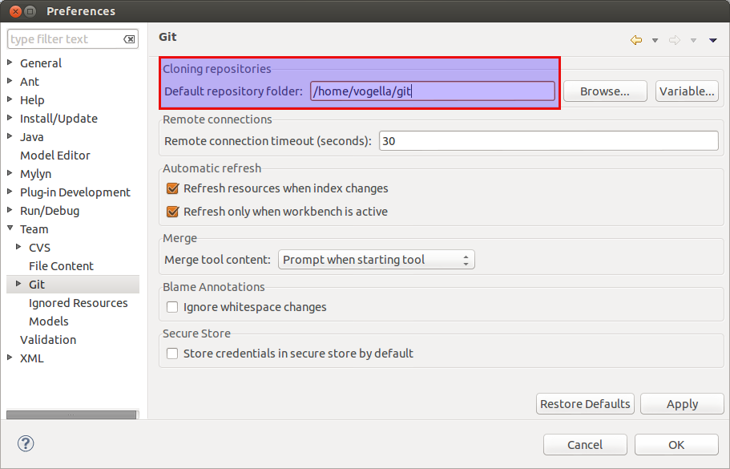

Mettre en conf un projet existant en local
- Click droit sur projet existant : team → share project → git → Next
- Clicker sur create pour créer un repository : donner un nom (ex : sportBetGitRepo) → Finish
- Pour mettre en conf sur serveur remote, il faut déjà que le projet soit en conf localement :
- Click droit sur projet → Commit ; renseigner commit message (ex : « First commit ») ; sélectionner tous les fichiers à commiter → Commit
- Puis mettre en conf sur serveur distant :
- Click droit sur projet existant : Team → Remote → Push
- Entrer URL repository distant (ex : https://github.com/Neostark/neostark.git.test.git) (les autres champs se complètent automatiquement en fonction de l’URL entrée) → Next
- Ajouter les références à Pusher : sélectionner source ref puis cliquer sur Add Spec → Finish → Ok.

Importer un projet déjà mis en conf sur serveur distant
File → Import → Git, Projects from Git → Clone URI
Entrer l’URI : https://github.com/Neostark/neostark.git.test.git ) (les autres champs se complètent automatiquement en fonction de l’URL entrée) → Next → Next
Renseigner le répertoire GIT (ex : neostark.git.sportBetGitRepo) → Next → Finish

Installation apache derby
Source : http://www.bhaveshthaker.com/31/database-development-using-the-eclipse-ide-derby-with-eclipse-data-tools-platform-in-java/
There are two separate Eclipse plugins for Derby
- derby_core_plugin – provides the Derby jar files to other plugins in Eclipse.
- derby_ui_plugin – provides an Apache Derby Nature in Eclipse for easy database application development.
Extract derby_core_plugin_[version].zip and derby_ui_doc_plugin_[version].zip. Copy folders available in plugins folder to eclipse > plugins directory.
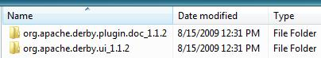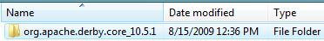
Restart Eclipse.
Now start Eclipse. Select File > New > Other. Expand Connection Profiles and select Connection Profile, click Next >.
Select Derby as Connection Profile Type. Name the Connection Profile for the host and database to which you’re connecting (i.e. localhost.database). We are giving name MyDerbyConnection. Click Next >.
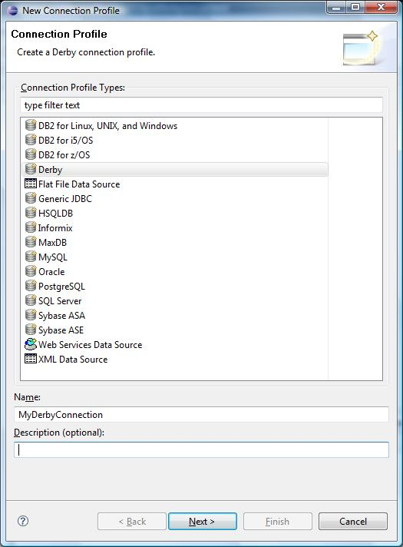
Specify a Driver and Connection Details as follows
- In Drivers drop down, select Derby Embedded JDBC Driver 10.2 Default.
- Check Save password option
- User name: admin
- Password: password
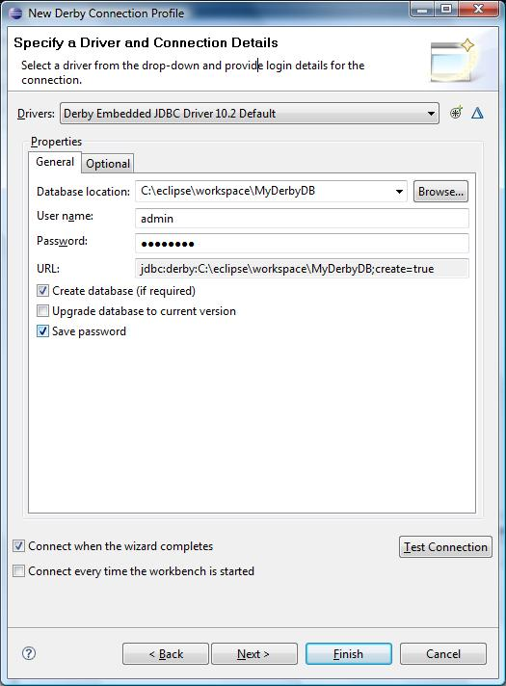
Click Test Connection. This will create Database Folder and ping success. Click Finish.
With a connection template and profile defined, open up the Database Development Perspective, if it isn’t already open.
Select Window > Open Perspective > Other…. Select Database Development, click OK.
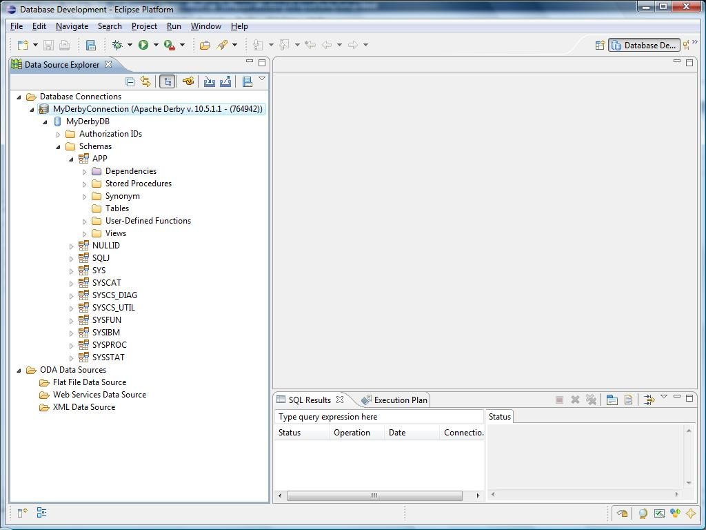
Add the Project Explorer view : Window → Show view → General - → Project Explorer → grab and drag the view from bottom to top left of Eclipse
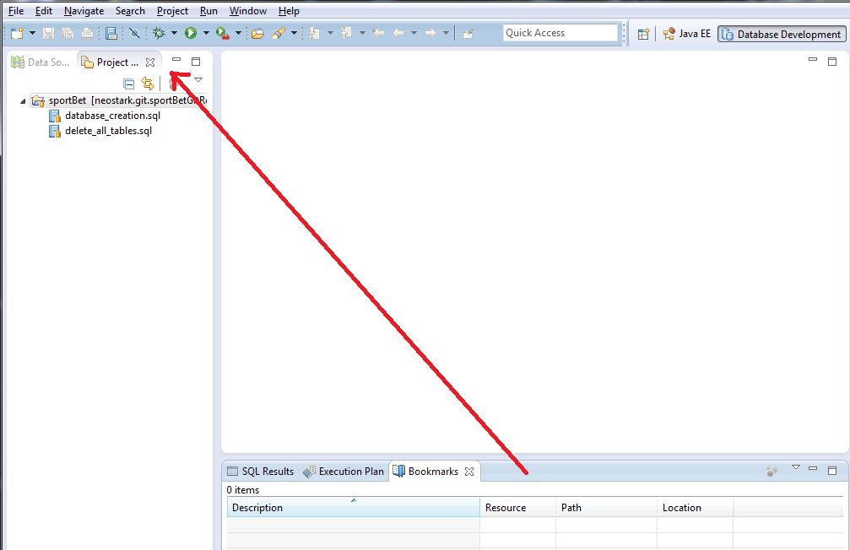

Build database for the first time

Right click on database_creation and click on : Execute SQL Files
The dabase is created. To check it, go to : Data Source Explorer view next to Project Explorer view (added before). In MyDerbyConnection → MyDB → Schemas → APP → Tables, right click on Tables and refresh. 5 Tables should be created.
Go back to Project Explorer view : right click on delete_all_tables.sql and choose Execute SQL Files (if asked select profile for the file as following )
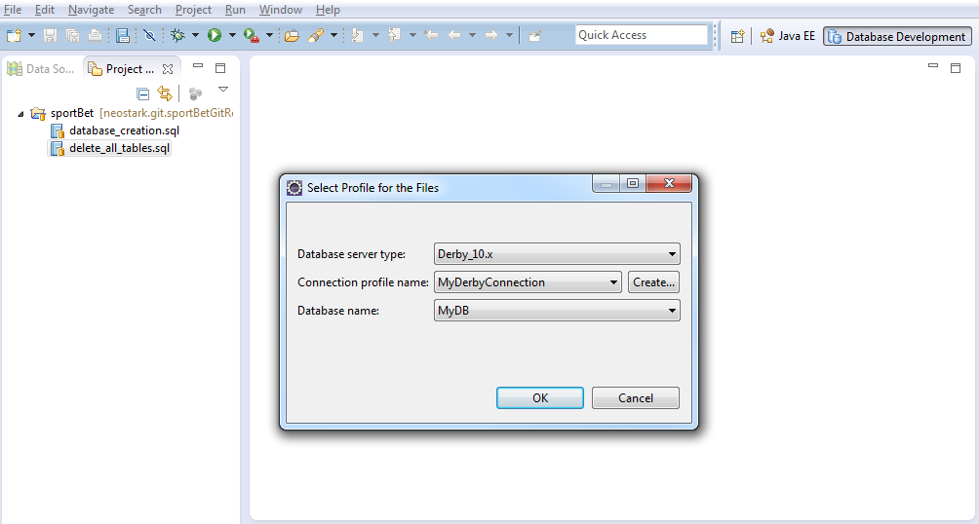
The tables created before are deleted. To check it, go to : Data Source Explorer view next to Project Explorer view (added before). In MyDerbyConnection → MyDB → Schemas → APP → Tables, right click on Tables and refresh. The 5 Tables should have be deleted.

